**Verify that the HDFS NFS Gateway is installed, started, and has exported the HDFS file system.**

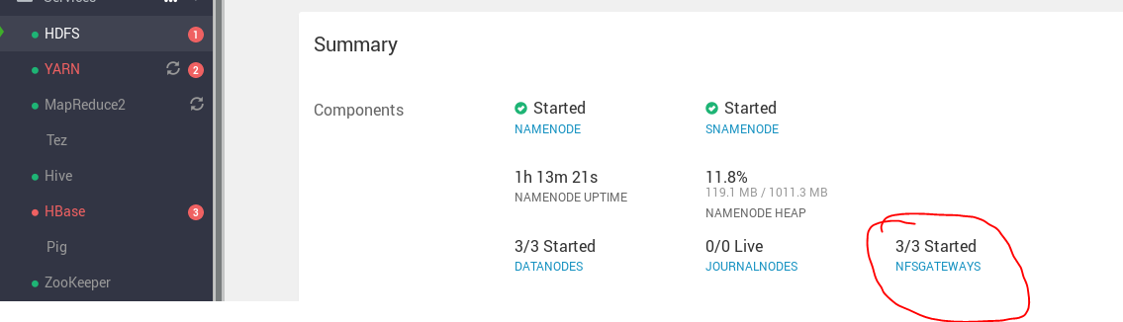

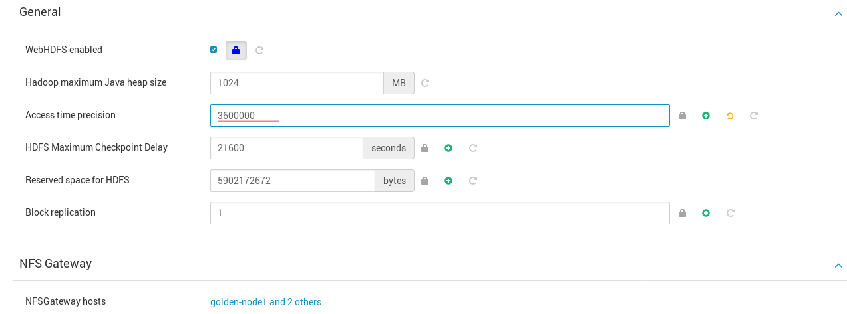

**Use the command-line interface to NFS mount the HDFS file system**



List the contents of the /hdfs_nfs directory

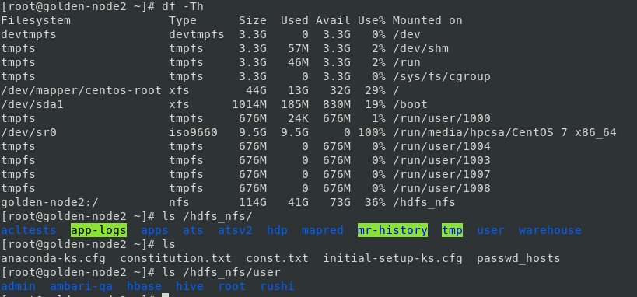

Copy the local passwd and hosts files to the root user’s home directory in HDFS. Verify that the file was copied.

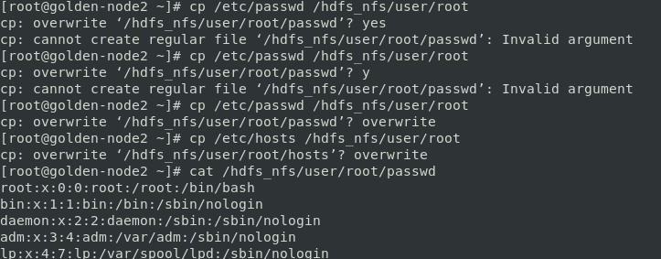

Remove the hosts file from HDFS.

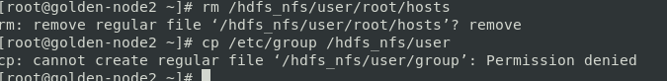

**Restrict NFS client mount permissions using the Ambari Web UI**

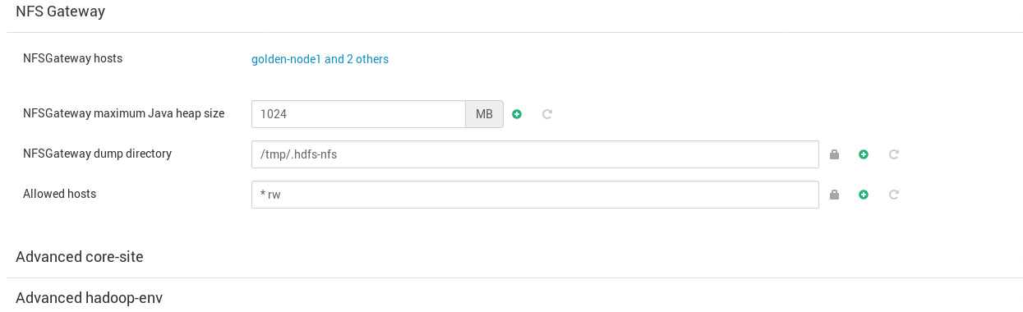

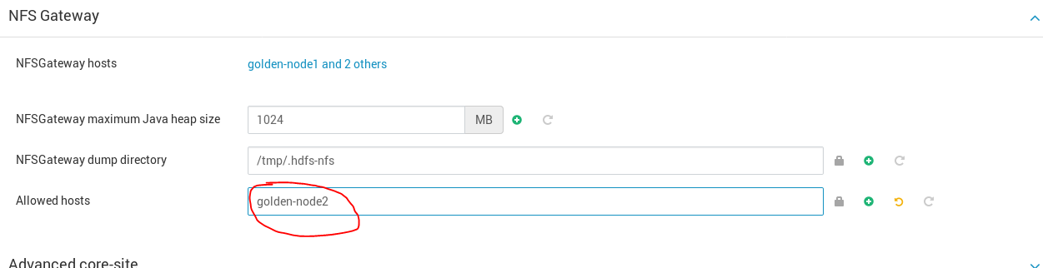

Create an empty directory to use as an NFS mount point and ensure that it is owned by the user hdfs.

